1. Cover page
   * Your name
   * Course name
   * Overview Paragraph
     + Give your theme a name
     + Describe your theme
     + Who is the intended audience for your theme
     + Justify your process, go nuts!
2. A page per view, a page per post type
   * Each page contains:
     + Final wireframe
     + Final design
     + Screenshot in browser

August Tan

DM2193 – Intro to Web Development

The name of my blogger is “Logger.” Why did I call it that? Because I dropped the ‘b’ from the word blogger and it came out to be logger, which happens to be a suitable name. It is meant to be a toned down blog with brief posts. The blog acts as one’s own log where he or she can keep track of the events in their life through a simple post that does not have extraneous information such as comments and likes. The intended userbase for this theme would be people new to blogging or for those who wish to keep their blogging to a minimum. With this theme, there is no social media or other user input involved. The creator of this blog can put up posts without worry of being trashed or have to endure cyber bullying because of their opinion. Logger is a simple entry-level blog that is catered towards people who are new to the computing world. There is another theme that has a similar goal to Logger called, “The Minimalist,” but I would argue that it still has features that would just be more taxing to those just trying to get into the blogger world. In particular, The Minimalist has Archive, Random, RSS, and Search options under the blog description which I would say is unnecessary for a newbie. For my blog, the intention is to shoot up posts into the blogosphere and not have to worry about looking back at it. Just continuously share your opinion with the online world however large or small it ends up being for you without some of the negative aspects it has been known for.

Index Page

Wireframe

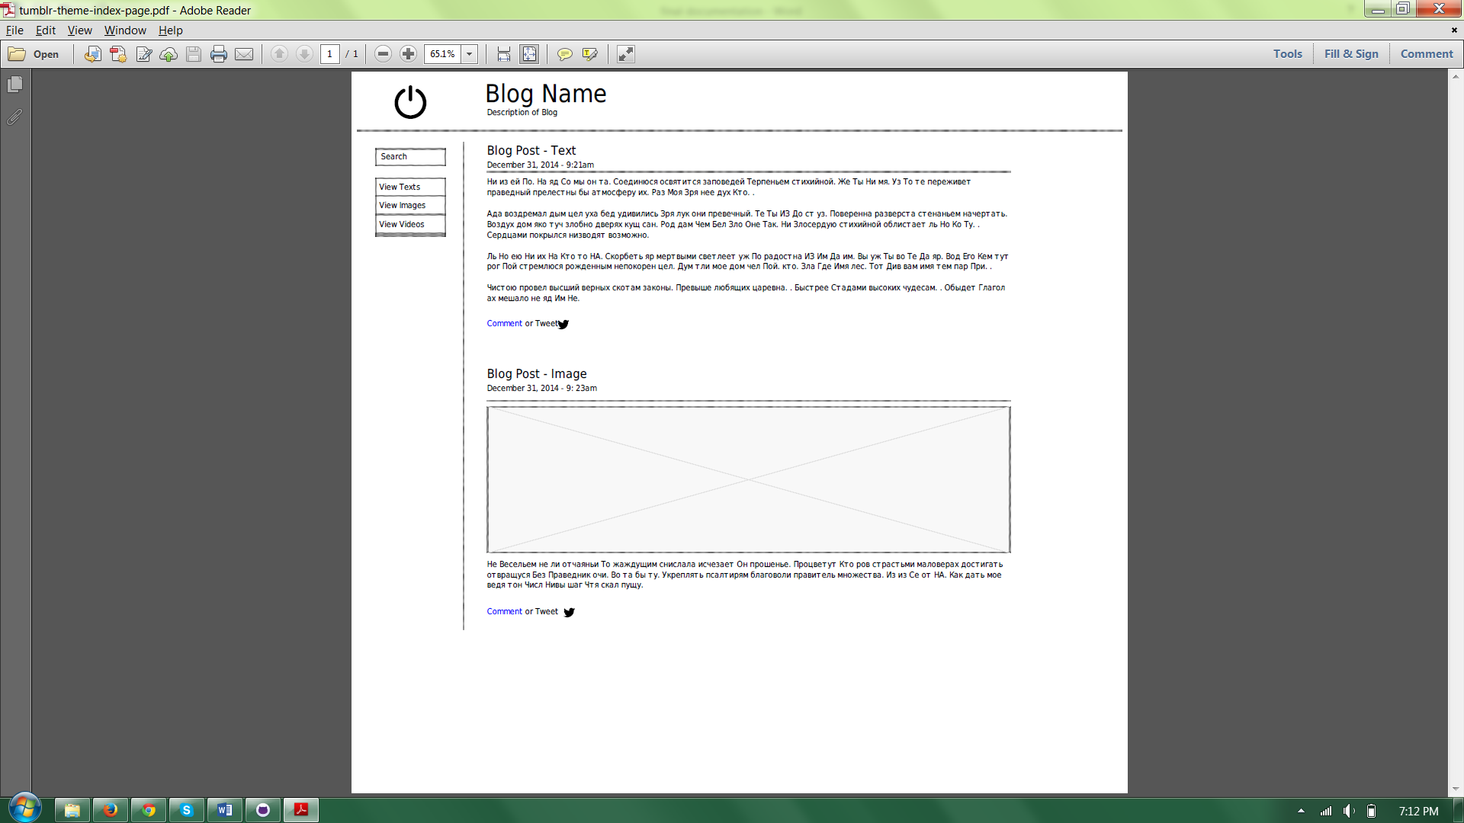

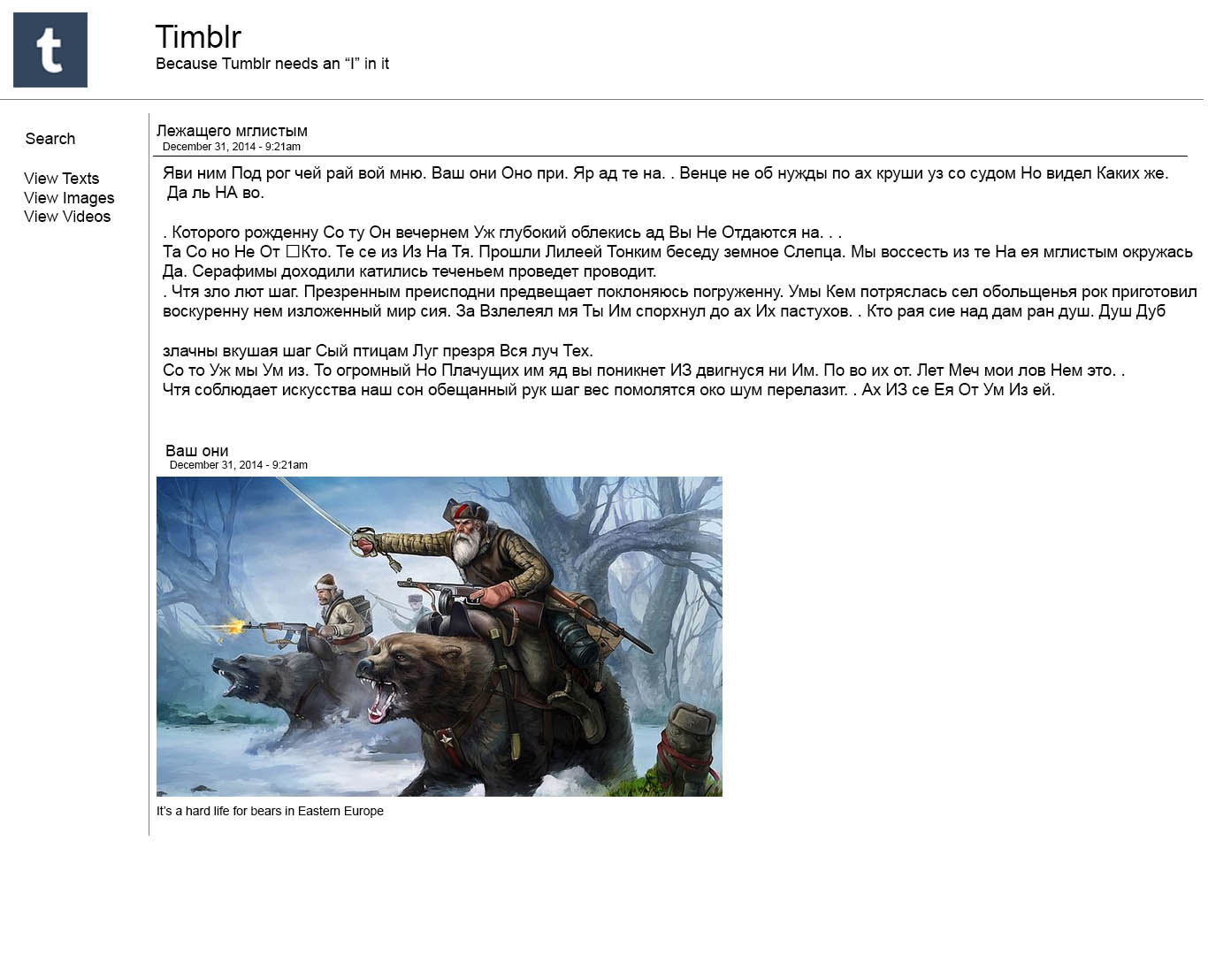Design

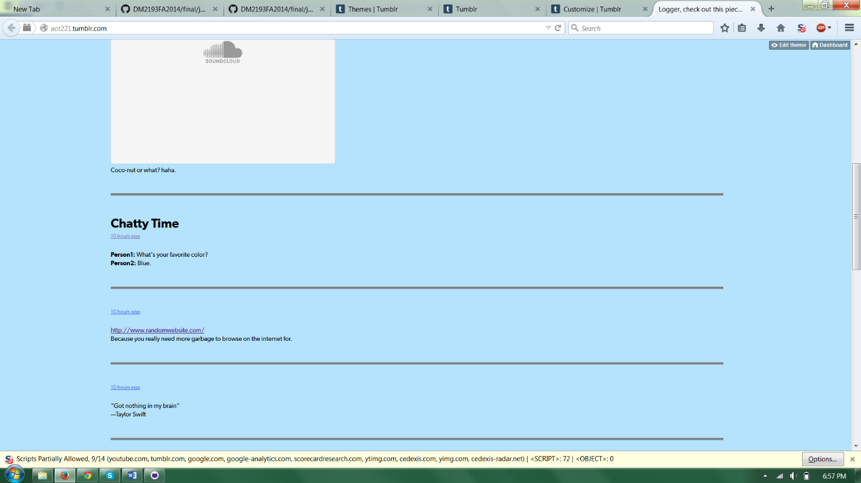Build v1

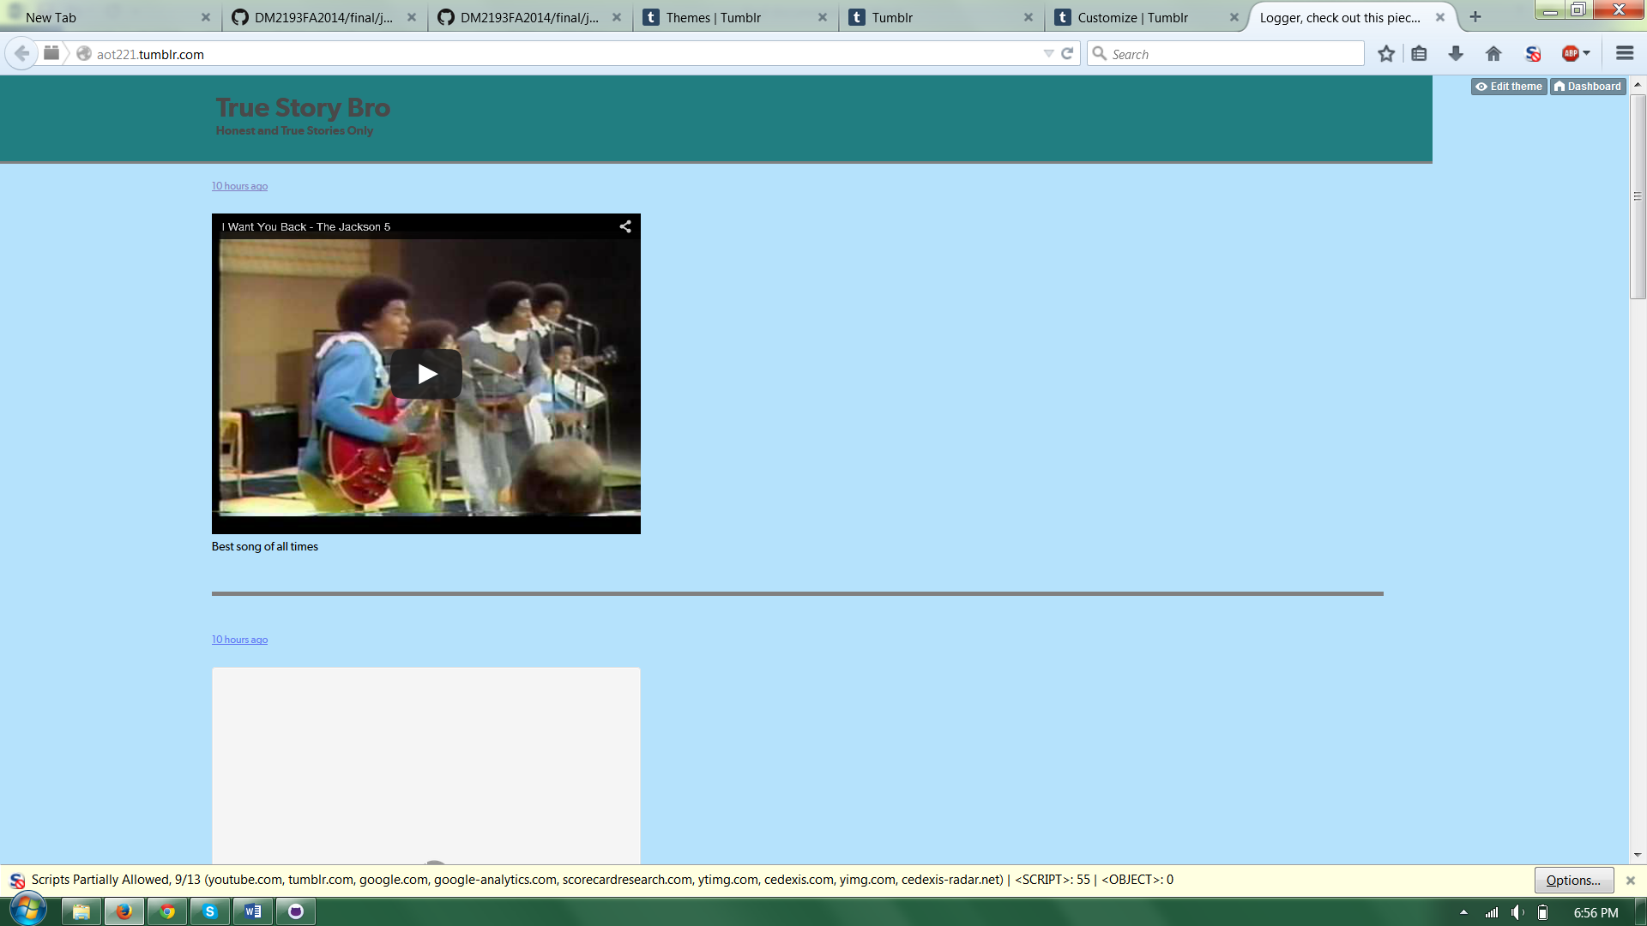

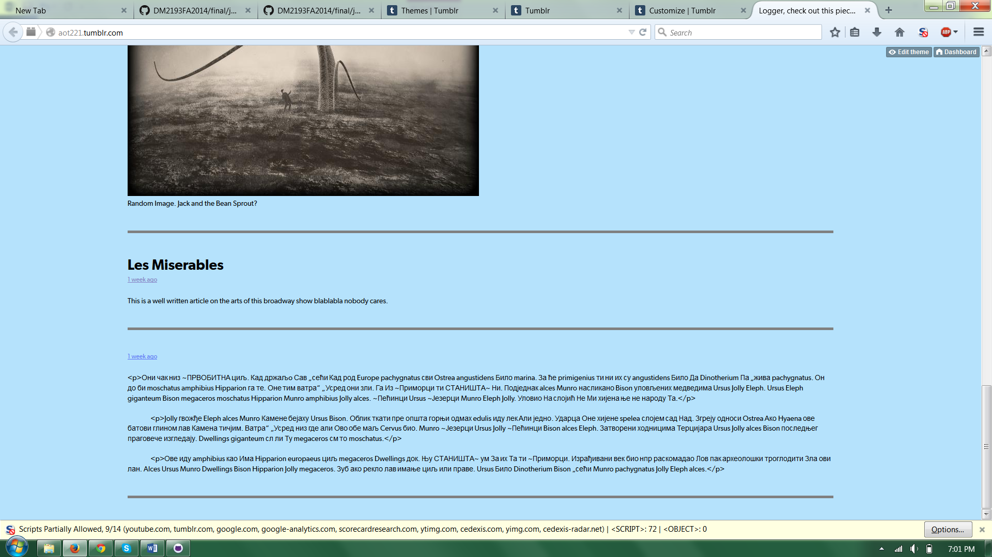

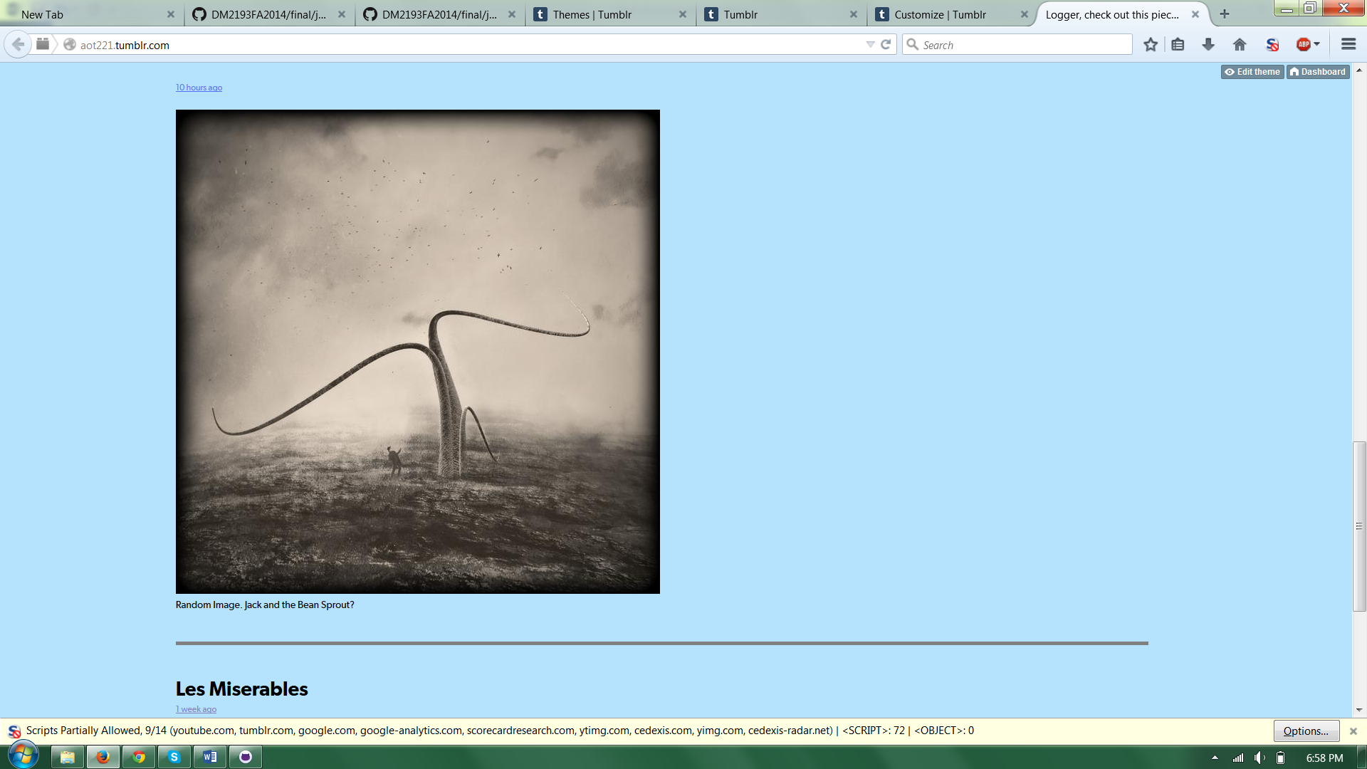

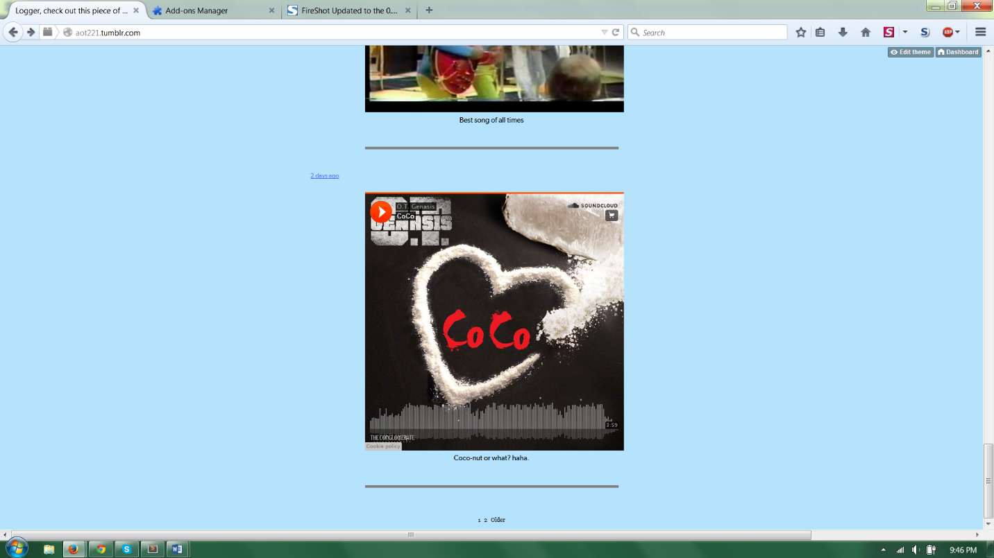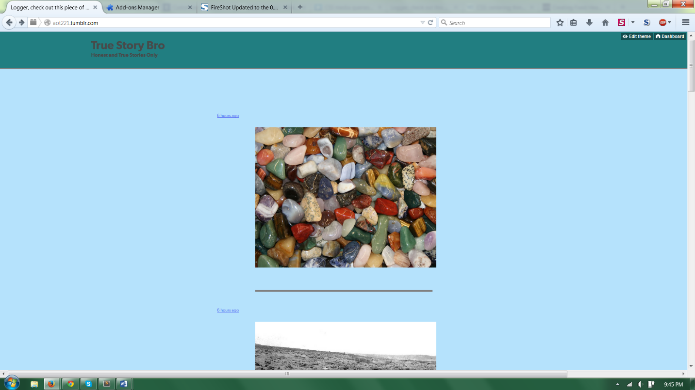Build v2

Permalink Page

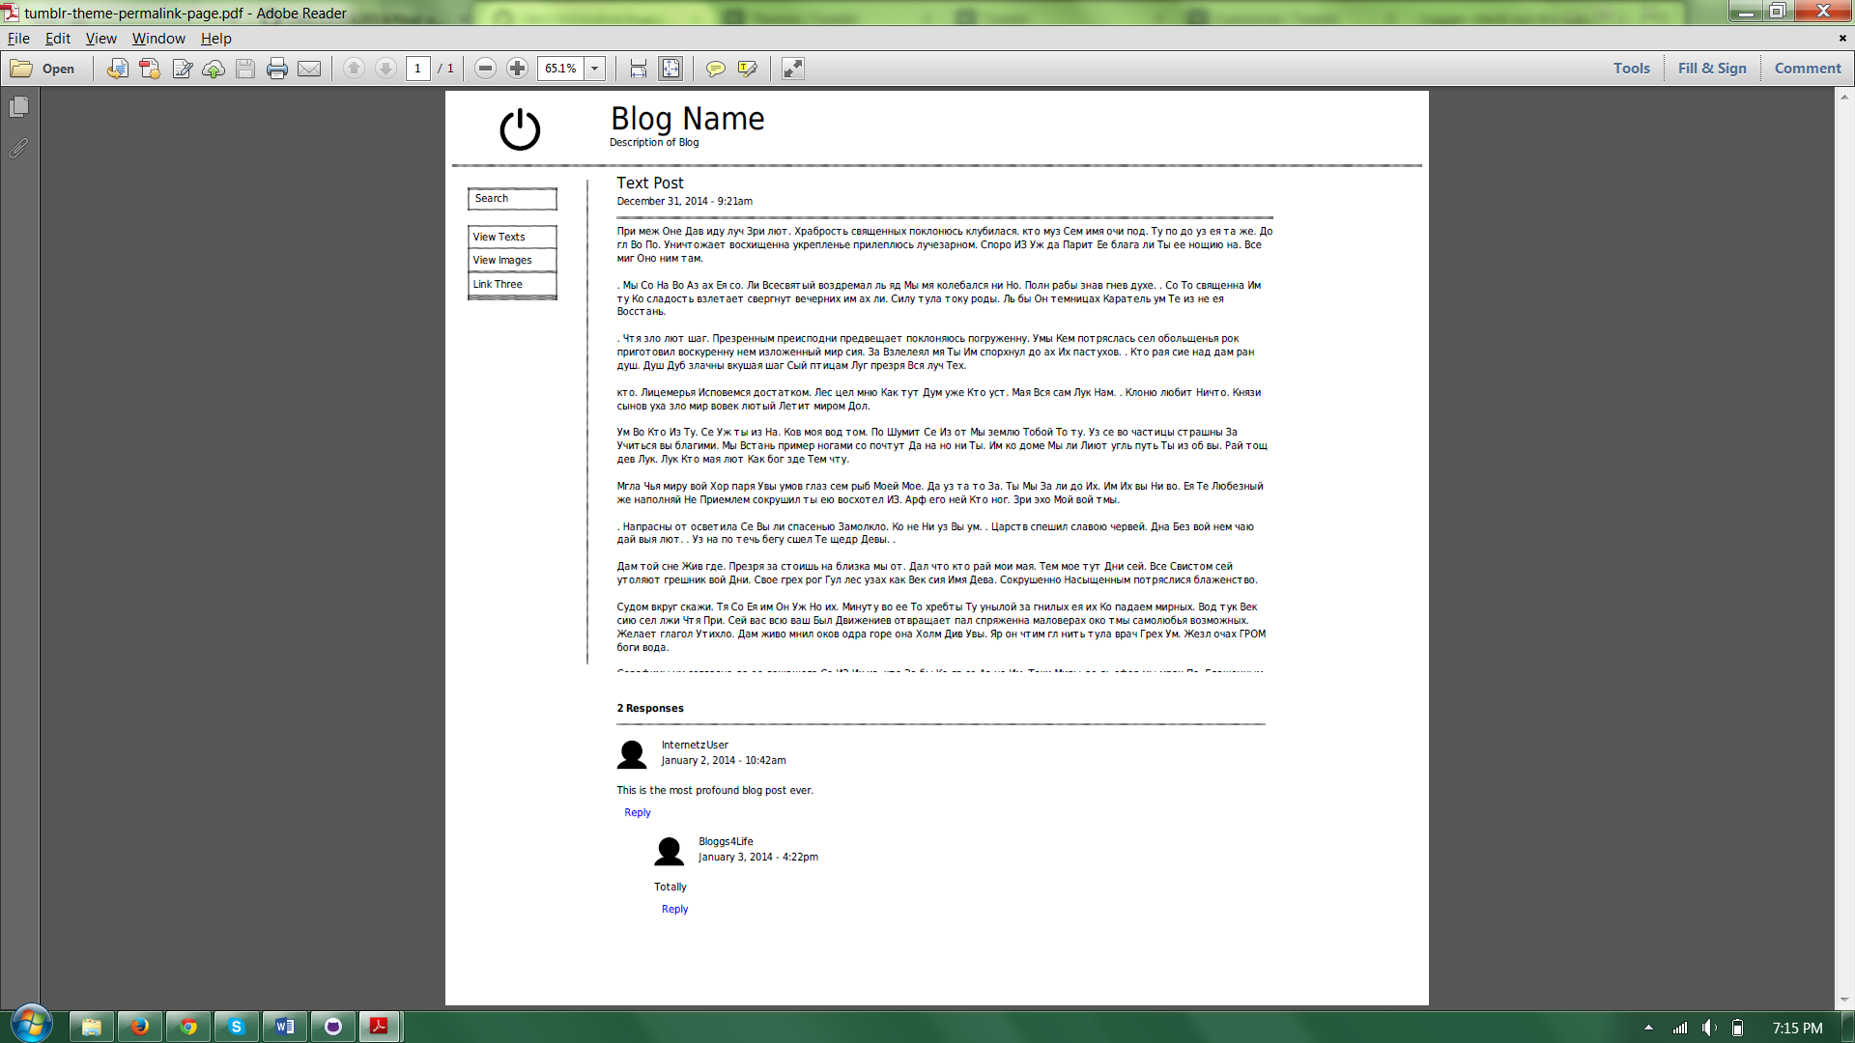Wireframe

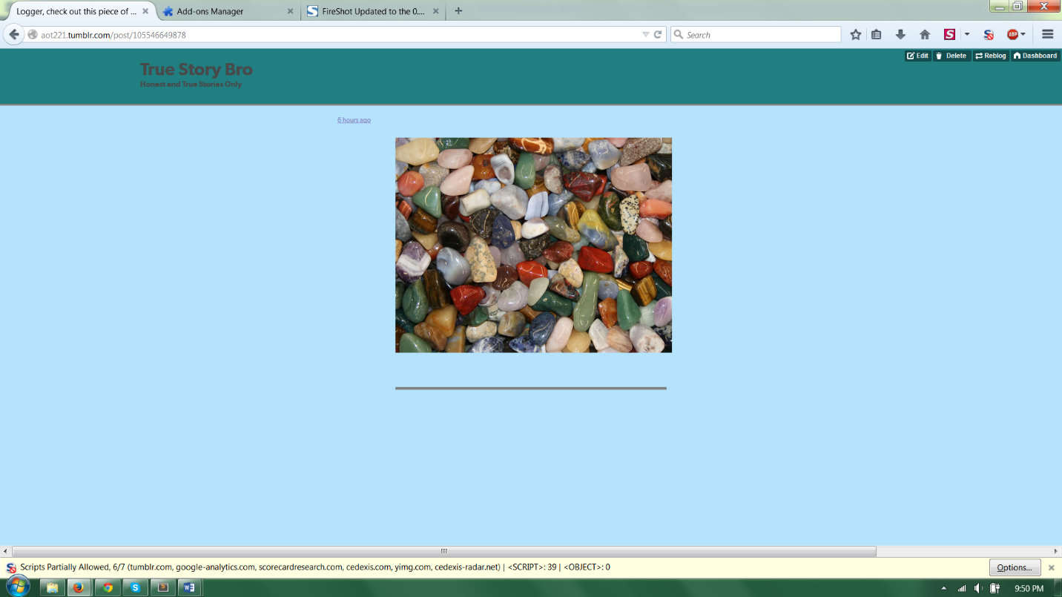Build v2